National Curriculum Intention(s):
Locational Knowledge
To name and locate the world’s 7 continents and 5 oceans.
Human and Physical Geography
To identify seasonal and daily weather patterns in the United Kingdom and the location of hot and cold areas of the world in relation to the Equator and the North and South Poles.
To use basic geographical vocabulary to refer to:
- Key physical features, including: beach, cliff, coast, forest, hill, mountain, sea, ocean, river, soils, valley, vegetation, season, and weather
- Key human features, including: city, town, village, factory, farm, house, office, port, harbour and shop.
Geographical Skills and Field Work
To use world maps, atlases and globes to identify the United Kingdom and its countries, as well as the countries, continents and oceans studied at this key stage.
To use simple compass directions (north, south, east and west) and locational and directional language [for example, near and far, left and right], to describe the location of features and routes on a map.
To use aerial photographs and plan perspectives to recognise landmarks and basic human and physical features; devise a simple map; and use and construct basic symbols in a key.

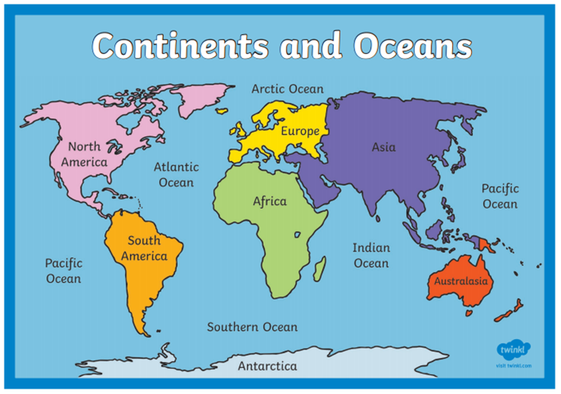
Key Numbers
7 continents | The land on the Earth is made up of 7 different continents.
5 oceans | Most of the water on the Earth is in the 5 connecting oceans.
71% water | The surface of the Earth is around 71% water.
96% salt water | Over 96% of the water on Earth is actually salt water.

Key Places
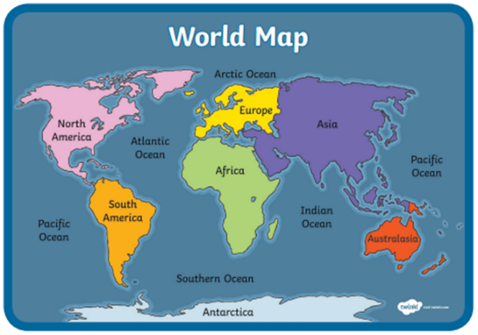
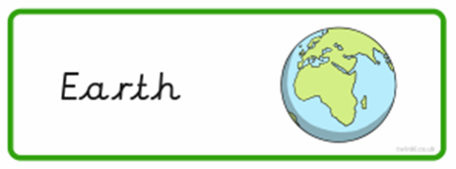 | The Earth is the planet that we live on.  The land on it is made up of 7 continents.  It is mostly water, which includes the 5 oceans.
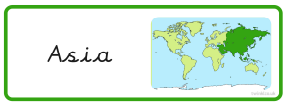 | Asia is the continent that is joined to Europe.  Most of the world’s population live in Asia.  The world’s tallest mountains, the Himalayas, are here.
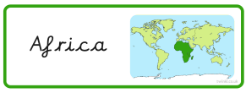 | Africa is the continent that is below (south of) Europe.  It is on the Equator.  It has the most (54) countries inside it.  The world’s longest river, the River Nile, is here.
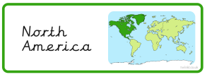 | North America is the continent joined to South America.  It is in the Northern Hemisphere (extending from Central America to the Arctic Ocean).
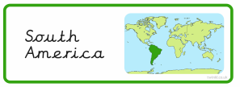 | South America is the continent joined to North America. It is mostly below the Equator and in the Southern Hemisphere.  The world’s biggest rainforest, The Amazon, is found here.
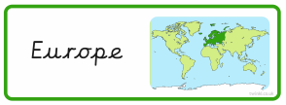 | Europe is the continent where we live.  It is in the Northern Hemisphere.  It is joined to Asia (which lies to the East of Europe).  Europe is made up of 44 different countries.
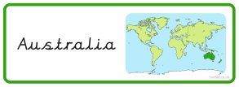 | Australia is both a country and a continent.  It is in the Southern Hemisphere and is below the continent of Asia.  The world’s largest coral reef, The Great Barrier Reef, is here.
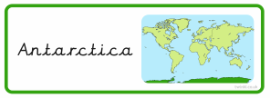 | Antarctica is the continent surrounding the South Pole. It is in the Southern Hemisphere and is surrounded by the Southern Ocean. It is almost entirely covered by an ice sheet.  It is the coldest and windiest continent.
Tier 3 Vocabulary
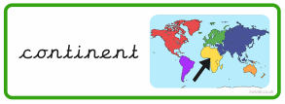 |  | A continent is a large land mass.  There are seven continents – Asia, Africa, North America, South America, Europe, Australia, Antarctica.
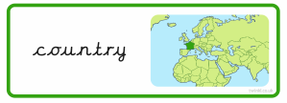 |  | A country is a region of land with its own government.  Some continents are made up from lots of countries. Some continents only have a few (or even just one country) in them.
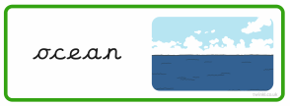 |  | An ocean is a very large expanse of sea.  It is a vast body of salt water that covers almost three quarters of the earth's surface.  There are five oceans – Arctic, Atlantic, Indian, Pacific and Southern.
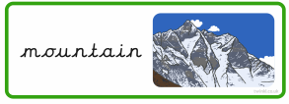 |  | Some continents have mountains.  The ‘summit’ is the highest point of a hill or mountain.
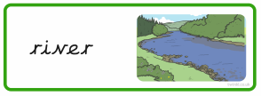 |  | A river is a large natural stream of water flowing in a channel to the sea, lake or another river.  Rivers travel across the land from a ‘source’ and flow out into the seas and oceans.
Coastline |  | The coastline is an area where the land meets the sea or ocean.
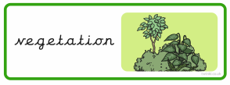 |  | The vegetation is all the plants and trees in a specific area.  The vegetation can vary between different regions and can include; forest, grassland, tundra (limited shrubs, grasses and mosses), desert and ice sheet (with no vegetation).
Population |  | The population of an area is the total number of persons inhabiting (living in) a country, city, or any district or area.

Subject Specific Vocabulary
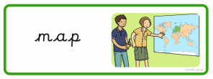 | A world map is a 2D (flat) representation of the Earth.
Atlas | An atlas is a collection of maps in a book.
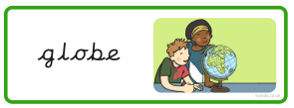 | A globe is a spherical (round) model of our Earth.
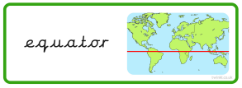 | The equator is an imaginary line drawn around the middle of the Earth. It is midway between the poles and divides the Earth into two hemispheres - the Northern Hemisphere and the Southern Hemisphere.
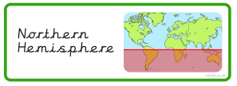 | The Northern Hemisphere is the (top) half of the Earth which is North of the Equator.
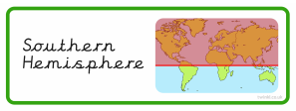 | The Southern Hemisphere is the (bottom) half of the Earth which is South of the Equator.
Climate | The climate is the weather conditions of an area or region (including the temperature and moisture).
Weather | The weather can be hot or cold, wet or dry. There can be wind, rain, hail, sleet or snow.  There can be sunshine, clouds, mist, thunder and / or lightning. The weather can change day to day and from season to season.
Tropical | Tropical means that it is hot and humid.
Humid | Humid means it is damp and warm.
