National Curriculum Intention(s):
- To develop an awareness of the past, using common words and phrases related to the passing of time.
- To know where people and events fit in within a chronological framework.
- To identify similarities and differences between ways of life in different periods.
- To ask and answer questions, choosing and using parts of stories and other sources that they know and understand key features of events.
- To understand some ways in which we find out about the past and identify different ways in which it is represented.
Timeline of Key Events
1199 – 1216  1215 | 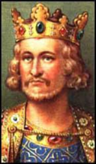  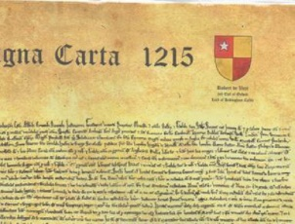  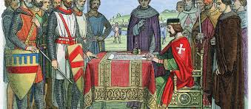  King John signed the Magna Carta on 15th June 1215.
1558 – 1603  1588 | 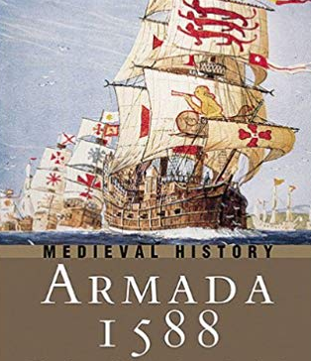  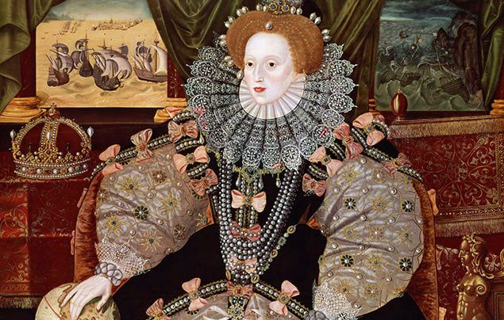  Queen Elizabeth I reigned for 45 years.  The Spanish Armada happened in 1588. (You will learn more about this in Year 2).
1625 – 1649  1649  1949 - 1660 | 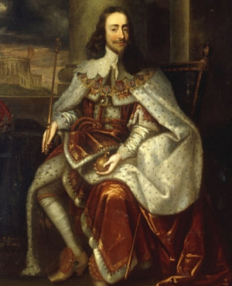  King Charles I was unpopular and quarrelled with the Parliament of England. A civil war broke out.  King Charles I was executed in 1649.  For a while there was no king or queen
1660 – 1685  1666 | 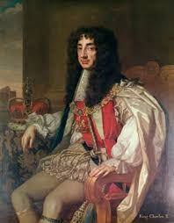  King Charles II returned (from hiding in France) to be king.  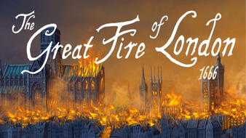  He was King at the time of the Great Fire of London.  The Great Fire of London happened in 1666. (You have learnt about this last term).
1837 - 1901 | 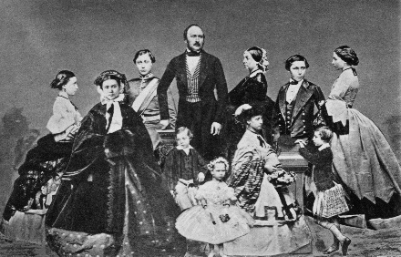  Queen Victoria’s reign lasted for 63 years, which is the second longest in British history.  She and her husband, Prince Albert, had 9 children.  (You will learn more about the Victorian era in Year 2).
1952 - present | 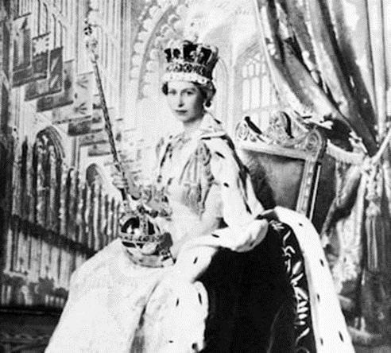  The coronation of Queen Elizabeth II took place on 2nd June 1953 at Westminster Abbey.  Elizabeth II is the longest reigning monarch in British history. So far, she has been ruling England for 66 years.  She is also the Queen of several other countries, including; Canada, Australia and New Zealand.

Key Places
London | 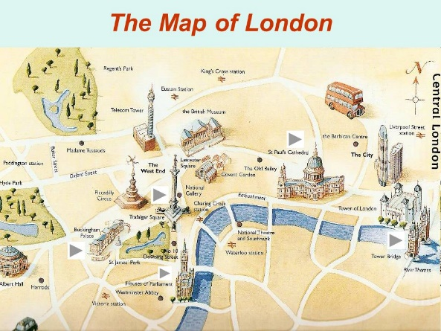  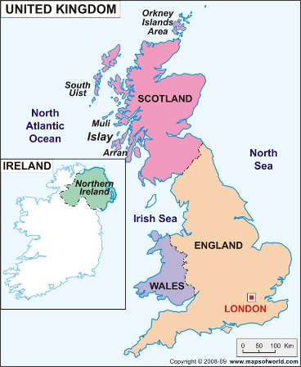  London is the capital city of England.  Buckingham Palace, Westminster Abbey and the Houses of Parliament are all in London.
United Kingdom | 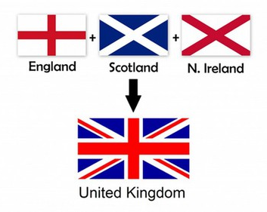  The United Kingdom is made up of four countries; England, Scotland, Wales and Northern Ireland.  The Union jack flag is the national flag of the United Kingdom.
Buckingham Palace | 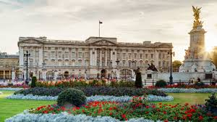  Buckingham palace is the place where the monarch of the United Kingdom lives when they are in London.
Westminster Abbey | 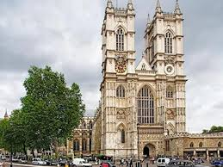  Westminster Abbey is in London. It is the place where kings and queens have their coronation ceremony.
Houses of Parliament | 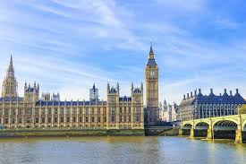  The Palace of Westminster is next to the River Thames in London. It is the meeting place of the Houses of Parliament where the government meet to make the laws and run the country.

Key Figures
King John.  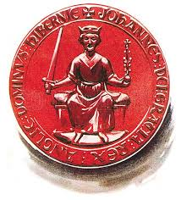 | 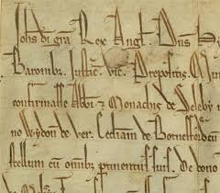  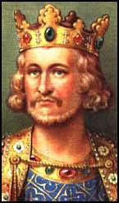  King John was an unpopular king but he signed the Magna Carta in 1215. This meant that he didn’t have as much power as before and he had to follow the law. It also allowed the formation of a parliament.
Queen Elizabeth I  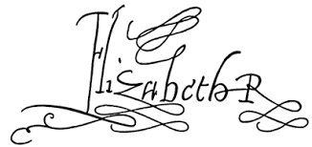  (1558 – 1603) | 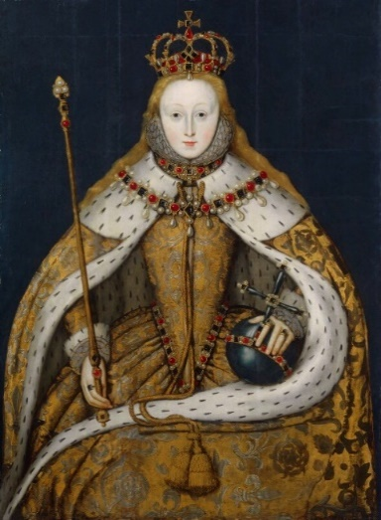
King Charles 11  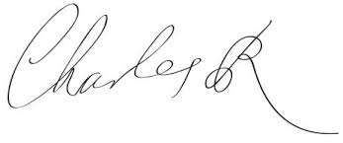 | 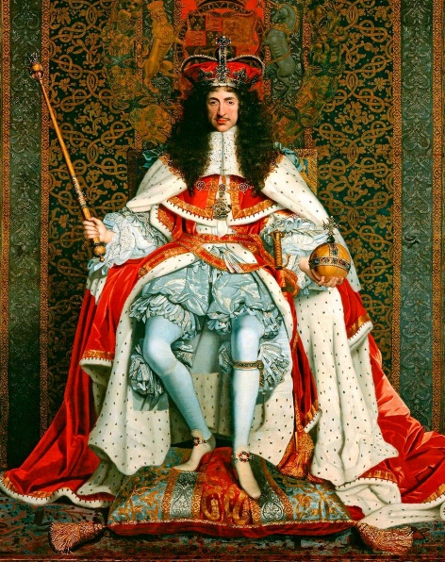
Queen Victoria
(1837 – 1901)

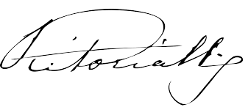
Elizabeth II  (1953 – present)  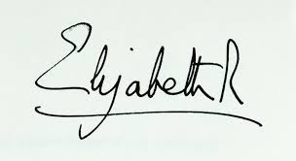 | Queen Elizabeth II’s father was King George VI. She is the longest reigning monarch in British history.  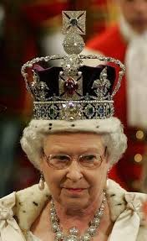  The Queen is now 93 years old.

Interesting Facts
Coronations have been held at Westminster Abbey since 1066, which is over 900 years!
The coronation of Queen Elizabeth II in 1953 was the first ever to be televised.
It was watched by 27 million people in the UK. It lasted almost 3 hours!

Tier 3 Vocabulary
Royal | A King or Queen or a member of their family.
Majesty | A royal person.
Monarch | A King, Queen or an Emperor that rules a country.
Crown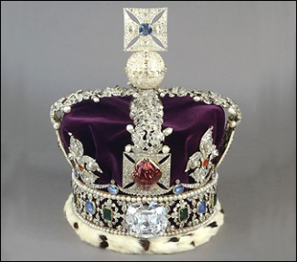 | 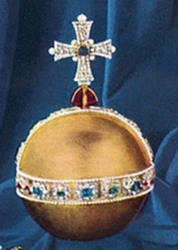  Orb | 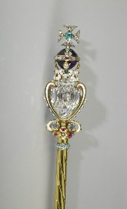  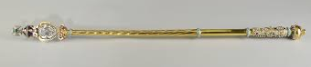  Sceptre | 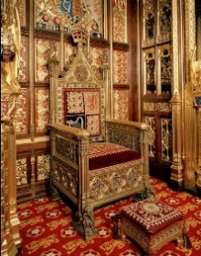  Throne
Crown | A crown is made from precious metals and jewels. It is worn by a monarch.
Orb | A royal orb is a symbol of power. It symbolises the earth.
Sceptre | A sceptre is a decorated rod carried by rulers on special occasions.
Throne | A throne is a special chair for a king or queen to sit in.
Coronation | A coronation is a special ceremony that takes place when a king or queen is crowned and starts their reign. The coronation of Queen Elizabeth II took place on 2nd June 1953 at Westminster Abbey.
 | 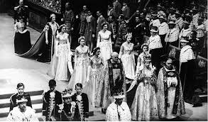
Reign | The time / period that a monarch is in charge and rules over the country.
Heir | 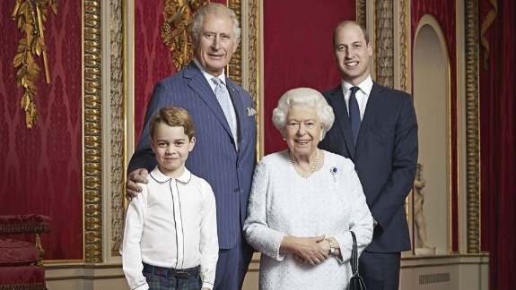  The person who is going to become King or Queen next.  Prince Charles is first in line to the British throne.  Second in line is Prince Charle’s eldest son, who is Prince William  Third in line is Prince William’s eldest child, who is Prince George.
Empire | A group of countries ruled over by one monarch.
The Magna Carta | A written agreement (like our class charter) that was signed by King John.
 | 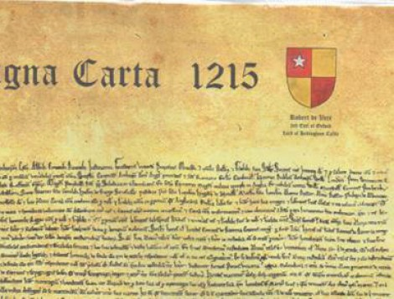
Government | The government is made up of people who are in charge of running the country.
Prime Minister | The head of the government.

Subject Specific Vocabulary
timeline | 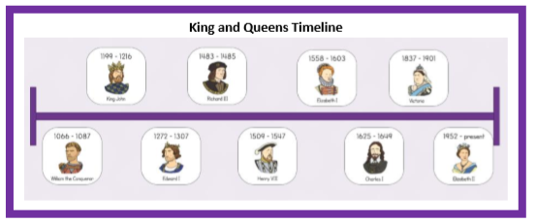  A timeline is a line on which important historical events are put on in the order that they happened.
chronological | If something is chronological then the events are sequenced in time order.
