Year 3 Homework Summer 1st Half Egyptians
Each week the children choose one learning activity from below and record into your home learning books. How the children research or present their findings is entirely up to them. They can use computers, books, observation, questioning or experimenting; draw, paint, write or build. The only requests are that the work be carefully and attractively presented and that children don’t copy out screens from books or the internet.
Throughout the week we set aside some class time for sharing the homework. Your support while your child is doing their homework is greatly appreciated but please do not be tempted to do it for them. The important things are that your child enjoys what they are doing, discovers something new and practises learning independently.
Your child should also read daily, practise spellings within their homework book and learn the statutory list for Y3/4 (some may still be working on Y1 and 2 spellings). They need to learn multiplication / division tables (you can use My Maths) for their Around the World Maths Assessments. Thank you for your continued support.
Please bring homework books in for a Wednesday to be marked and returned by Friday. Larger homework projects/ computer based project can be brought in at any time and will be shared at the end of a day with the class.
1 Dojo Home Learning Point You have completed your home learning and made some effort. We would like to see more consideration over the content and /or presentation of your learning. |  | 2 Dojo Home Learning Points This is good home learning; you’ve clearly put some thought into it and put a sensible amount of time into your learning |  | 3 Dojo Home Learning Points Very impressive learning! You must have put lots of thought and effort into this learning and it’s clear that you enjoyed doing this.
Maths  LI = (Learning Intention) | LI: to be able to apply known number facts.  If I know that 8 x 4 = 32, what else do I know?  Think of all the related facts – see how many you can show. |  | LI: to be able to solve problems, including missing number problems, involving addition and subtraction.  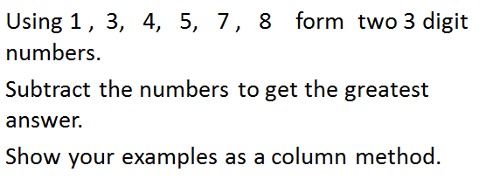 |  | LI: to be able to compare durations of events.  Make a note of some activities you do at the week end or evenings, when you start, when you finish and calculate how long you have spent doing them.
English | LI: to be able to apply features of a story to your own writing.  Write your own story which is set in Ancient Egypt.  It could be a mystery, adventure or legend – you decide! |  | LI: To be able to apply spellings (including topic words)  Choose at least 5 words that you are learning at the moment and use them each in a sentence.  Can you also find the definitions of your words? |  | LI: to be able to apply poetry features to your own writing.  Can you write a riddle describing an Egyptian object, person, etc.  We can share them in class and see if we can guess what it is!  Or  Write your choice of style of poem using your topic learning and descriptive language.
Topic  Ancient Egypt | LI To understand how are knowledge of the past is constructed through different sources  Use different sources to find out about the past and record key facts. Record the key vocabulary and their definitions. |  | LI To construct informed responses that involve thought and organise historical information  Write a report about Ancient Egypt. Use generalisers e.g. Sometimes/ Most/ The vast majority/ On the whole |  | Use printing technques to create your own Ancient Egypt Image.
 |  |  |  |  | Use different materials to create your own Egyptian Pyramid. Consider how the materials join together. Write instructions about how to make your pyramid. Use Time Adverbial’s: First/ Next/ Then/ After
Science  Light | LI To recognise that the sun can be dangerous and know how to protect your eyes  Create a sun safety poster supporting people to keep their eyes safe. |  | LI To recognise that shadows are formed when light from a light source is blocked  Create your own Shadows at home. Measure the length of the shadows throughout the day. |  | LI To notice that light is reflected from surfaces  Use a mirror to explore how light behaves when it is reflected from a mirror. Record your results.
Essential Home Learning:
- Know your multiplication facts for 2/3/4/5/8/10
- Be able to spell in words numbers to 100
- Be able to spell all the words from the Year One and Two list
- Read every day, on some days complete a reading menu activity and record in your yellow reading record or your home learning book.
Enjoy!

