Year 3 Homework Spring 1st Half Movement and Motions
Each week the children choose one learning activity from below and record into your home learning books. How the children research or present their findings is entirely up to them. They can use computers, books, observation, questioning or experimenting; draw, paint, write or build. The only requests are that the work be carefully and attractively presented and that children don’t copy out screens from books or the internet.
Each week we will set aside some class time for sharing the homework. Your support while your child is doing their homework is greatly appreciated but please do not be tempted to do it for them. The important things are that your child enjoys what they are doing, discovers something new and practises learning independently.
Your child should also read daily, practise spellings within their homework book and learn the statutory list for Y3/4 (some may still be working on Y1 and 2 spellings for this term). They need to learn multiplication / division tables (you can use My Maths) for their Around the World Maths Assessments. Thank you for your continued support.
Please bring homework books in for a Wednesday to be marked and returned by Friday. Larger homework projects/ computer based project can be brought in at any time and will be shared at the end of a day with the class.
1 Team Point You have completed your home learning and made some effort. We would like to see more consideration over the content and /or presentation of your learning. |  | 2 Team Points This is good home learning; you’ve clearly put some thought into it and put a sensible amount of time into your learning |  | 3 Team Points Very impressive learning! You must have put lots of thought and effort into this learning and it’s clear that you enjoyed doing this.
Maths | LI: to be able to apply known number facts.  If I know that 8 x 3 = 24,  What else do I know?  Surprise me with as many facts as you can! |  | LI: to be able to solve problems, including missing number problems, involving multiplication and division.  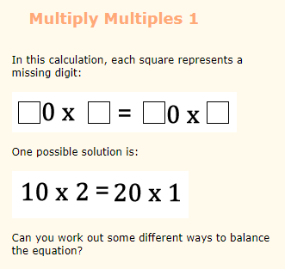 |  | LI: to be able to make reasonable estimations.  When you go shopping, estimate how much the total cost of the bill will be. How accurate was your estimate? Write the details in your homework book Find the difference between the estimate and the actual cost.
English | LI: to be able to apply features of a newspaper report to your own writing.  Is there a current news story that you are particularly interested in? Or can you write a news report about a school or community event. It may get chosen to be in the school newsletter! |  | LI: To be able to apply spellings (including topic words)  Design a word search or a crossword using the words that you are learning at the moment, topic words or a mixture of both. |  | LI: to be able to apply poetry features to your own writing.  Can you write a poem inspired by our topic of movement and motion? This can be any style of poetry and may be about mechanical movement and motion or maybe a Cornish mine.
Topic  Movement and Motions | Find out about mining in Cornwall. Create a poster. |  | Create your own 3D sculpture using materials of your choice. |  | Locate where mines are in Cornwall.
 | Write a newspaper report about a mine in Cornwall. |  | Create your own moving item using a pulley and cogs. |  | Create your own movie maker about a story of your choice!
Science  Forces and Magnets | 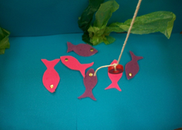  Create your own Magnetic fish game. |  | 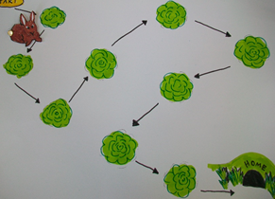  Create your own magnetic track/ games using objects with paper clips, split pins. |  | Test the objects at home. Which are magnetic and which are not magnetic? Record your results.
Essential Home Learning:
- Know your multiplication facts for 2/3/4/5/8/10
- Be able to spell in words numbers to 100
- Be able to spell all the words from the Year One and Two list
- Read every day, on some days complete a reading menu activity and record in your yellow reading record or your home learning book.
Enjoy!

