Key Vocab
Motte: The hill that a castle sits on
Bailey: The village surrounded by a wall
Keep: Castle
Goal: meaning prison
Portcullis: A French word meaning ‘sliding door’ is a heavy vertically closing gate typically found in medieval fortifications, consisting of a latticed grille made of wood, metal, or a combination of the two, which slides down grooves inset within each jamb of the gateway
Norman times: The Norman Conquest began in 1066, to the devastating Black Death of 1348, the Hundred Years’ War with France and the War of the Roses, which finally ended in 1485.
Tapestry: Is a form of textile art.
Memorial: is an object, which serves as a focus for a memory of commemoration of something, usually an influential, deceased person or a historical tragic event.
Priory: is a monastery of men or women under religious vow.
Monks: A monk is a man who has devoted part or all of his life to religion.
Quaker: are members of a group with Christian roots that began in England in the 1650s.
Ruins: are the remains of a manmade structure.
Reservoir: A French word meaning a tank to store water.

Knowledge Organiser – Year 3 Rebellion and Invasion

Charles Causley (CBE, FRSL) was born on 24 August 1917 in Launceston. His first play ‘Runaway’ was published when he was only nineteen. His poetry includes many references to Cornwall and its legends, his stature being recognized by his appointment as a Bard of the Cornish Gorsedd in 1955. In 1958 Causley was made a Fellow of the Royal Society of Literature and he was awarded a CBE in 1986. Other awards include the Queen’s Gold Medal for Poetry in 1967. Causley was a very quiet and modest man. His readings were noted for the respect he always gave to his audience. Charles Causley died in 2003. His grave may be seen next to that of his mother in the cemetery by St Thomas Church where his grave simply says ‘Poet’.

Launceston Castle was built as a wooden structure first and later built in stone. It is a Norman structure called a Matte and Bailey. The castle dates back to 1067.

George Fox was held in Launceston Castles Jail for 9 weeks whilst awaiting trial. He was put in the jail for having long hair. When he finally went to court his name was cleared, but he refused to pay for the keep of his horse whilst he was awaiting trial and was put back in jail. He wrote lots about the bad conditions of the jail.

Launceston for many years was a market town and had cattle markets and butter markets held daily and weekly. It was also the county’s main court and jail until the assizes moved to Bodmin in 1842. The last execution in the castle ground was in 1821.

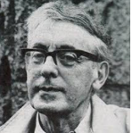
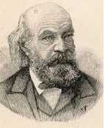
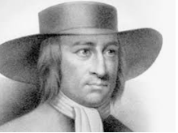

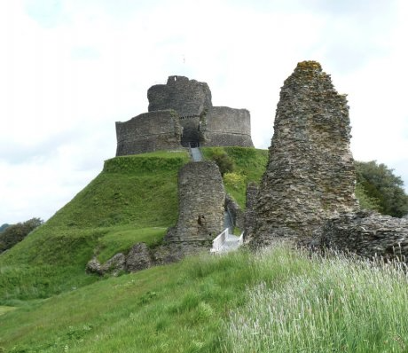
People:
John Couch Adams; July 1841 discovers Neptune
Charles Causley: Local Poet
George Fox, Part of the Quakers and was held in Launceston Goal.
St Cuthbert Mayne, Missionary Catholic Priest.
Charlotte Dymond 18 year old murdered on Bodmin Moor

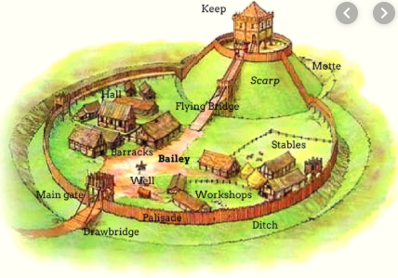

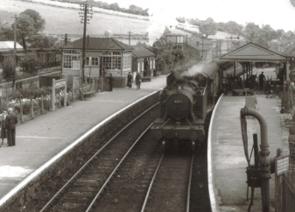

Important Places:
Launceston Castle and Castle Green, Priory, Railway, St Mary Magdalene Church, War Memorial/Old Butter market, White Hart Hotel, Town Hall, Eagle House Hotel, Lawrence House Museum, St Stephens.
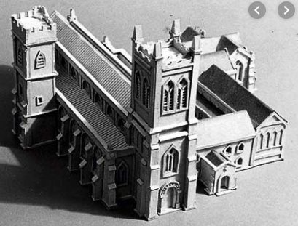

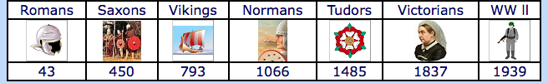

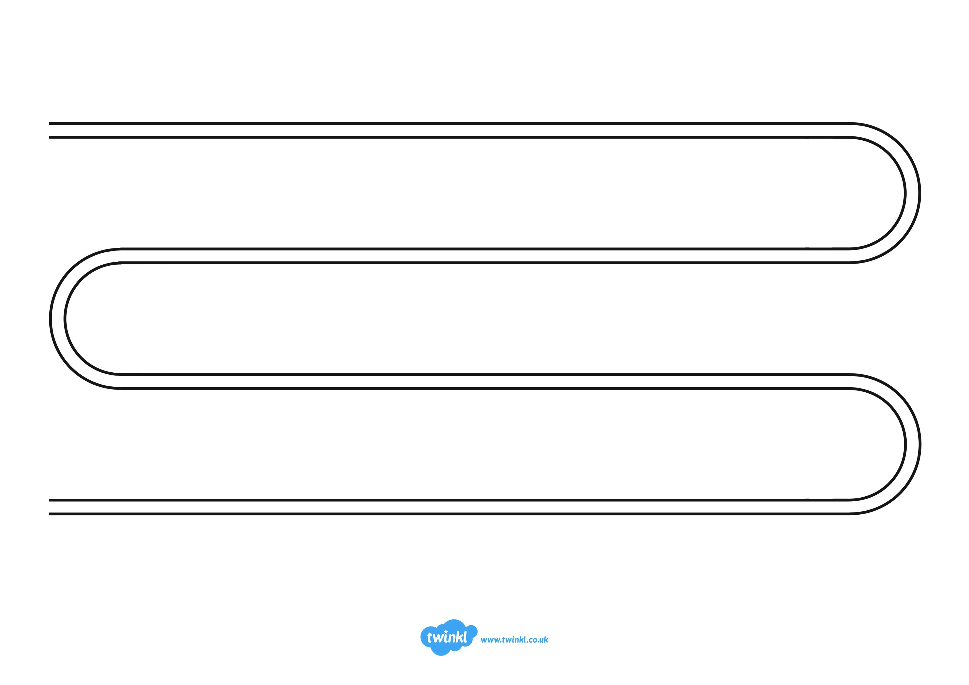
1067
Robert Count Mortain (1/2 brother to William conquer) Built wooden Castle
Launceston Castle
1067-68
Revolt in Exeter Norman V Saxon
1086
Doomsday survey mentions castle
1106
Crown takes over castle
William 11
1141
Reginald Dunstaville (illegitimate son of Henry 1)
1175
John (Brother of Richard 1)
Stone keep on top of castle.
1191
Crown took over castle
Gate houses rebuilt in stone.
1225
No Earl just constables looking after castle
1227-1272
Richard of Cornwall (Earldom granted by Henry 111 his older brother).
1227-1272
Castle defences renovated, high tower built with roof, small tower added, wall built around. North and South gatehouses reformed with solid towers. Bridge and ditch. Rebuilding in Baily.
1272
Edmund
(Richards’s son)
1337
Edward The Black Prince
Castle wall in ruins and roofs needed attention.
1341 Repairs to castle started.
1353 Black Prince now Duke of Cornwall.
1650
Chapel and Hall levelled
Repairs: Rekilly Chamber. Queens Hall. Justice Chamber, Council Chamber, Great Hall, Bailey divided into 2
Civil War.
Prison and courtyard brought by county and used as a jail
1764
Constables lodgings North Gate demolished.
1779
John Howard
1821
Last execution at castle
1842
Assizes moved to Bodmin. Jail demolished.
1940
US Army built huts and hospital.
1951
Duchy of Cornwall
Prince Charles.
1984
English Heritage.

