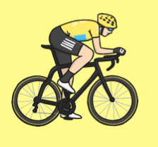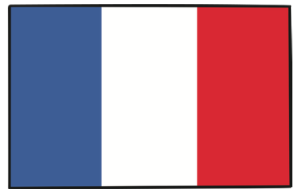

The Tour de France is the world’s longest and most well-known cycle race. It covers over 2,200 miles through France and happens every year. It takes place over 23 days and only includes two rest days.

The history of the Tour de France: Before the Tour de France, cycling became very common in France for many people. Organised bike racing was introduced and professional cycling became very popular in France, so the race was born. The first ever winner of the Tour de France was Maurice Garin, who died in 1903.

Today’s Race and Route: Each year the race begins in a different country. The route also changes every year, but it always finishes in Paris. Every day is a new stage of the race and each stage winner gets to go up onto the podium. Different winners get to wear different coloured jerseys including the yellow jersey, the green jersey, the polka-dot jersey and the white jersey. The overall winner of the Tour de France is the cyclist who has ridden the full route in the quickest time, but doesn’t have to have been in the lead all the time.

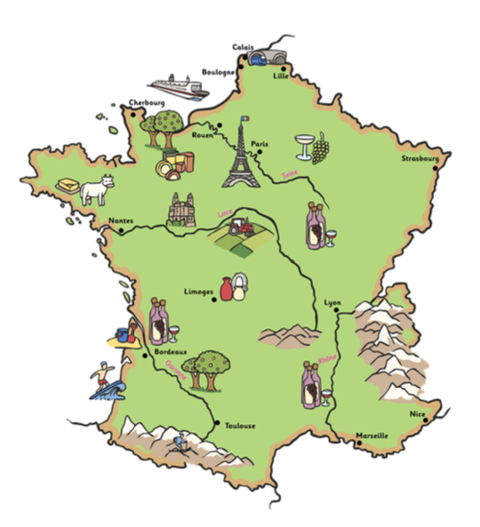

Year 3 Natural Elements

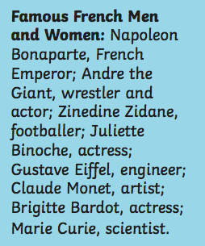

Population in France is over 62.2 million people.

Capital City is Paris

Languages: French 88% other languages are: English, Spanish, Portuguese, German, Italian and Arabic. Continent: Europe

Mountains: Alps, Massif Central, Jura and Pyrenees

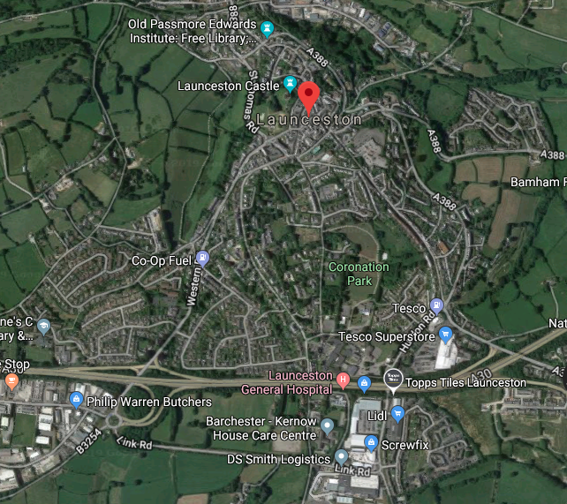

**French Food:**

Le lait milk

Le fromage cheese

Le glace ice-cream

Une pomme apple

Une orange orange

Une fraise strawberry

Une prune plum

Une mangue mango

Un citron lemon

Une nanane banana

**Key Vocabulary:**

aerial, symbols, observational, landmark, surrounding, fieldwork, north, south, east, west, coordinates, ordinate survey, map, tropics, equator, hemisphere, latitude, green band, coast, ocean, sea, beach, cliff, sketch, photo, physical features, river, forest, hill, soil, vegetation, weather, season, human features, town, village, factory, farm, house, office, church, school, castle, library, train station, shop.

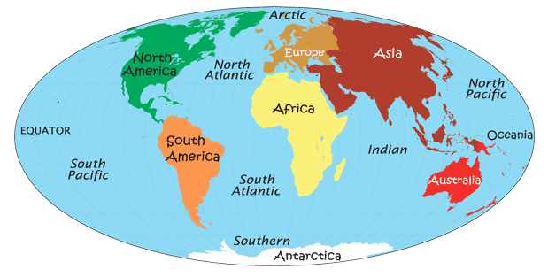

There are 7 Oceans in the world: Artic Ocean, North Atlantic Ocean, Southern Atlantic Oceans, Indian Ocean, North Pacific Ocean, South Pacific Ocean, and Southern (Antarctic) Ocean. There are 7 continents of the world: North America, South America, Africa, Europe, Asia, Australia, Antarctica,

There are 24 languages spoken in Europe. Ireland is not a country in the UK. The English Cannel separates France from the UK. Russia has the largest population in Europe. The population in France is over 62.2 million!