**Art: Collage**

*What materials will you use to create a collage?

*Can you name any famous college artists?

*What do you about Henri Rousseau?

*At Home: Create your own 3D images of something of your own choice. You can choose your materials.*

**Geography**

*Can you locate the countries with rainforests?

*What are the physical characteristics of rainforests?

*At Home: Research the locations of the Rainforest in the World. Find out about the animals that live in the Rainforest.*

**Music: The Dragon Song**

*Can you remember sounds in music?

**Year Three**

**Spring 2 2019**

**MFL :French- Celebrations**

*Do you know any French celebrations?

*Can you say any celebration greetings?

**Our Learning Journey and how you can help at home**

**PE: Swimming and Games**

*Can you swim a length in the swimming pool? *Can you work as a team to score a goal or team point?

**Rainforests**

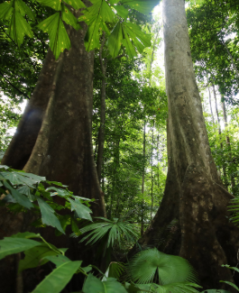

**Computing – We are network engineers**

*Can you use some diagnostic tools to investigate network connections?

*How are domain names converted to IP addresses?

*At Home: Explore Sites offering access to networking tools via the*

*web: http://centralops.net/co, www.ultratools.*com, http://network-tools.com.

**RE: Sikhism: Who are the Sikhs?**

**\*Do you know any Sikh symbols?**

*At Home: Find out about Sikhism- their symbols and their celebrations.*

**Enrichments Monday 25th February**

Project Hook: Monday 25th February Create a rainforest classroom!

Friday 1st March Watch Film: Rio!

**Thursday 28th March: 3pm Come and visit our Rainforest gallery in the Classroom.**

**English**

**Stories with Imagery** linked to our class learning about rainforests. Focus on adjectives to describe the scene.

**Report Non Chronological** write about key aspects of the rainforest.

**Poems to Perform** Learn Poems to recite and perform to the class out loud.

**Spellings**

**Y3/4 words**

*Children will be focusing on making sure they spell their Year 1 and 2 common exception words in their day to day writing and beginning to explore their new words.

**Reading**

*Make sure you are reading regularly at home and are recording it.*

**Science: Plants**

* Can you identify the functions of different plants?

* Do you know the way water is transported in plants?

*What do you know about the life cycle of flowering plants?

*At Home: Go for a walk and find different plants. See if you can name them. Draw and identify their features. Do all plants need the same items to stay alive?*

**Maths**

**Statistics:** Plot data into graphs with different scales.

**Length and Perimeter:** Find the length and calculate a perimeter.

**Number: Fractions:** Find the fractions of amounts.

**SMSC: Good to be Me!**

*Can you name different surprises?

*Can you name worries people may have?

*At Home: What makes it good to be you? What are your special qualities?*