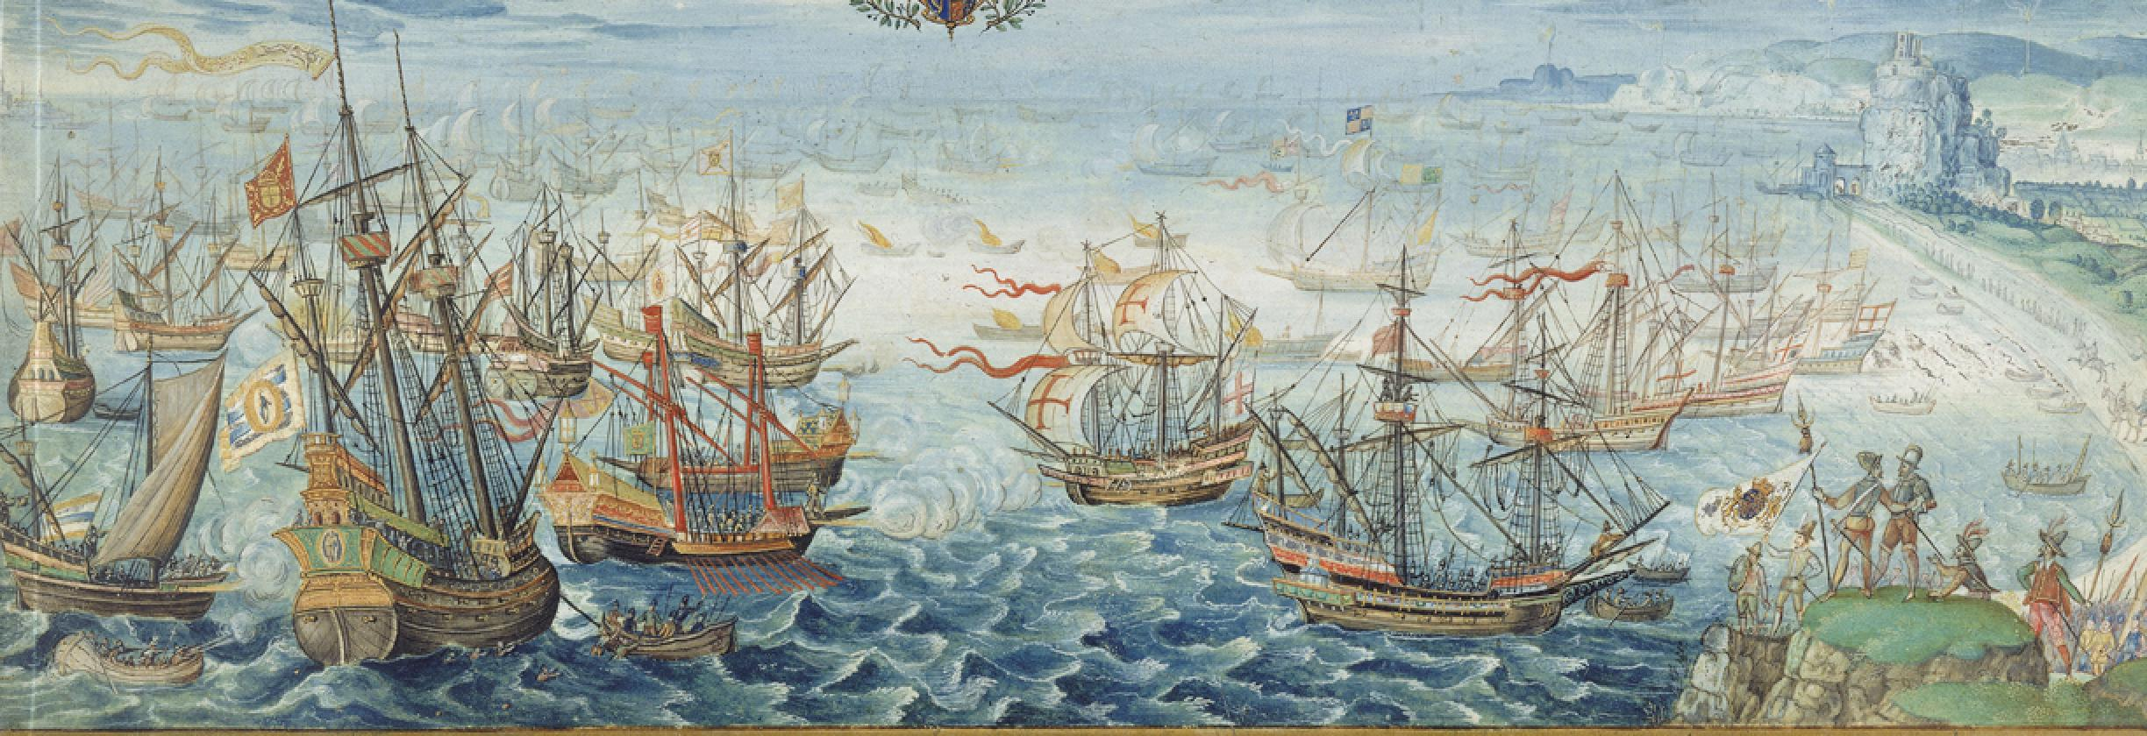

**The Spanish Armada**

What was the Spanish Armada?

A fleet of 130 Spanish ships were sent to invade England under the command of the Duke of Medina Sidonia.

Why was the Spanish Armada semt?

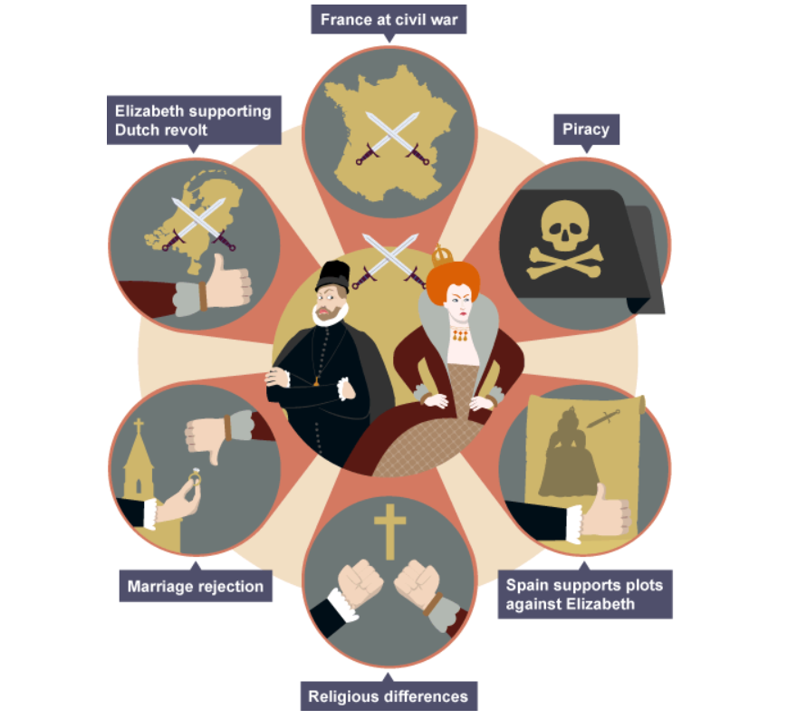

The Events of the Armada

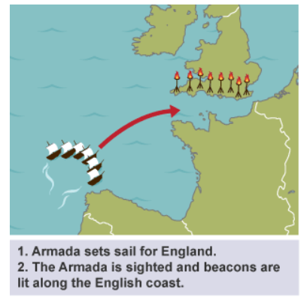

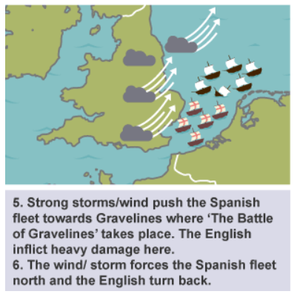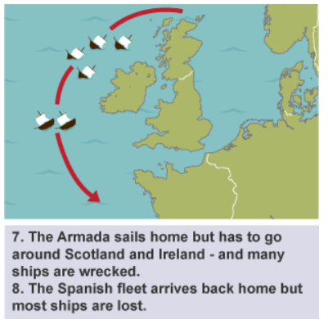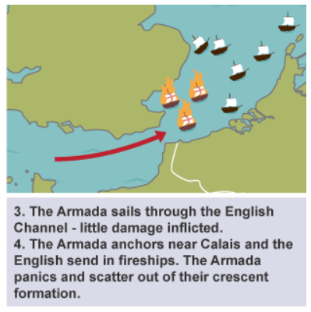

Key People

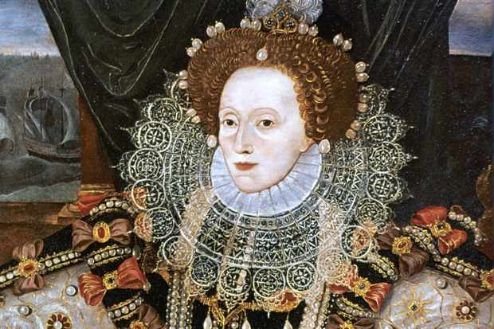 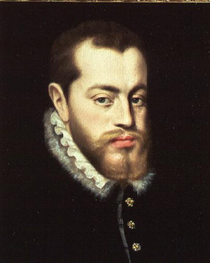 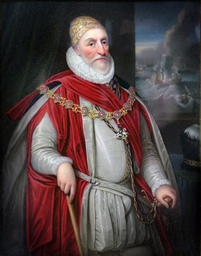 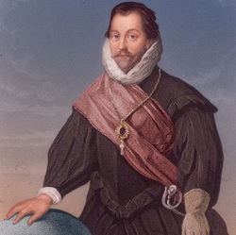 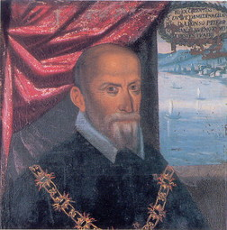

Queen Elizabeth I King Philip II Lord Howard of Effingham Sir Francis Drake Duke of Medina Sidonia

Queen of England King of Spain Lord Admiral of England Vice Admiral of Navy Spanish Commander of Armada

Key Vocabulary

|  |  |
| --- | --- |
| Armada | a fleet of warships |
| Navy | sea-borne branch of the armed forces |
| Revolt | take violent action against the government or ruler |
| civil war | a war between people from the same country. |
| Invade | to go into a place by force to try and take possession of it. |
| fireship | a ship loaded with burning material and explosives and set adrift to ignite and blow up an enemy's ships |
| crescent formation | The ships were grouped into a curved line which was wide in the middle and tapered at each end |
| New World | North and South America |
| privateer | sailor employed by the crown to attack or capture foreign ships |

* **Sir Francis Drake was allegedly playing bowls on Plymouth Hoe when the Armada was sighted. He is said to have remarked that there was plenty of time to finish the game before tackling the Spanish fleet.**

The only ships that the English fleet lost were the eight fire ships which they had deliberately set against the Spanish at Calais.

The ships of the Armada, lined up in a convoy, stretched for over two miles!

The Spanish Admiral Medina Sidonia had never commanded a navy and was unhappy about taking up his post.