National Curriculum Intention (s):
- A study of an aspect or theme in British history that extends pupils’ chronological knowledge beyond 1066.
- The changing power of monarchs.

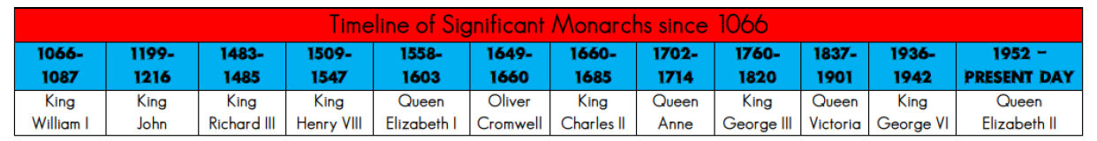
Key Information
King John 1119-1216
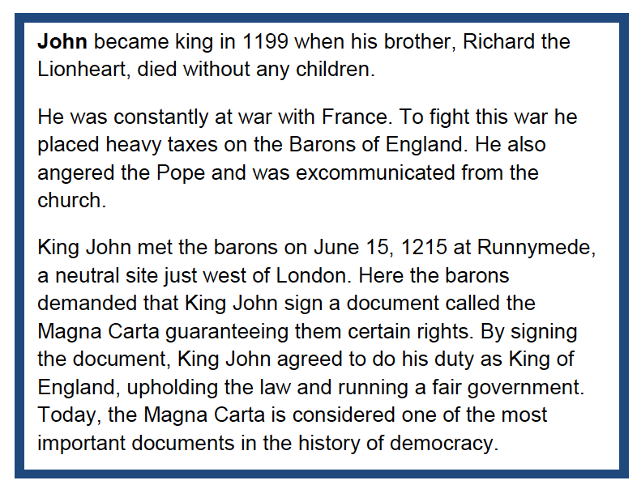 | 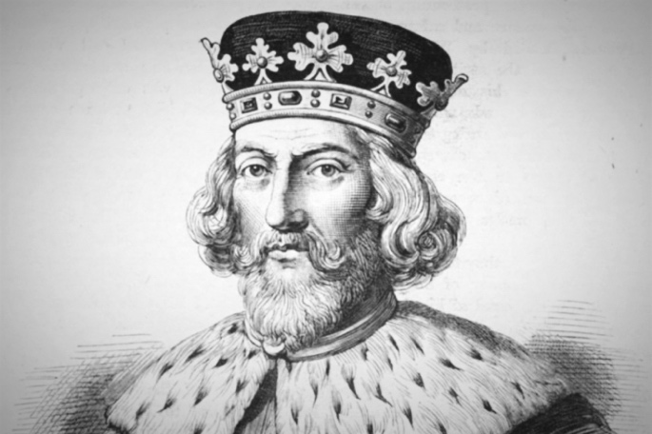
Henry VIII 1509 -1547
Henry VIII is the most well know of the Tudor kings. He was a selfish man and many people were afraid of him, mainly because of his ruthless succeeded the throne after his father’s death on 21st of April 1509. He was 17 years old when he became king.  Henry wanted a son to rule after him. He first married Catherine of Aragon and wanted to divorce her when she did not produce a male heir to the throne. The Roman Catholic Church refused to grant the divorce so Henry established the Church of England. In total he married 6 times: Catherine of Aragon (divorced), Anne Boleyn (executed), Jane Seymour (died), Anne of Cleves (divorced), Catherine Howard (executed) and Katherine Parr (outlived Henry).  During his 38 year reign, he had more than 70,000 people executed. | 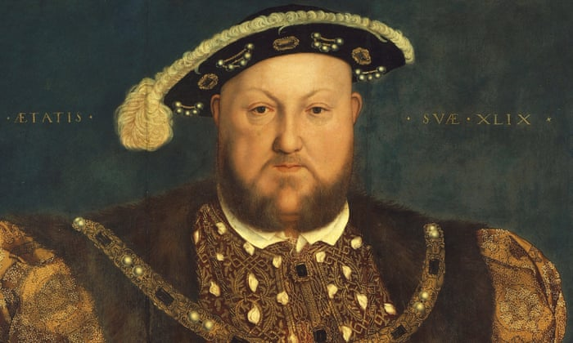
Queen Elizabeth I 1558- 1603
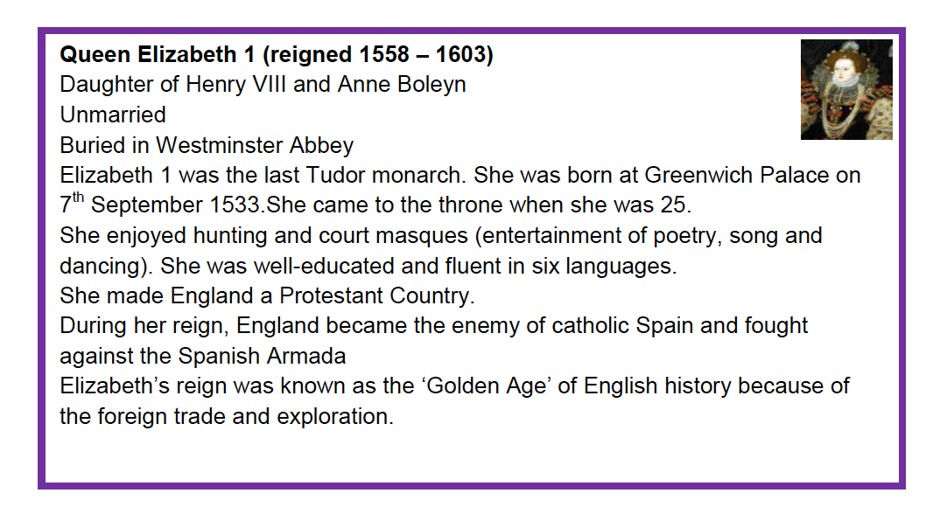 | 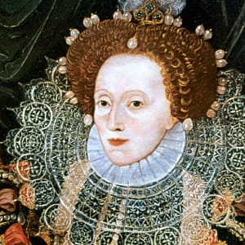
Queen Victoria 1837-1901
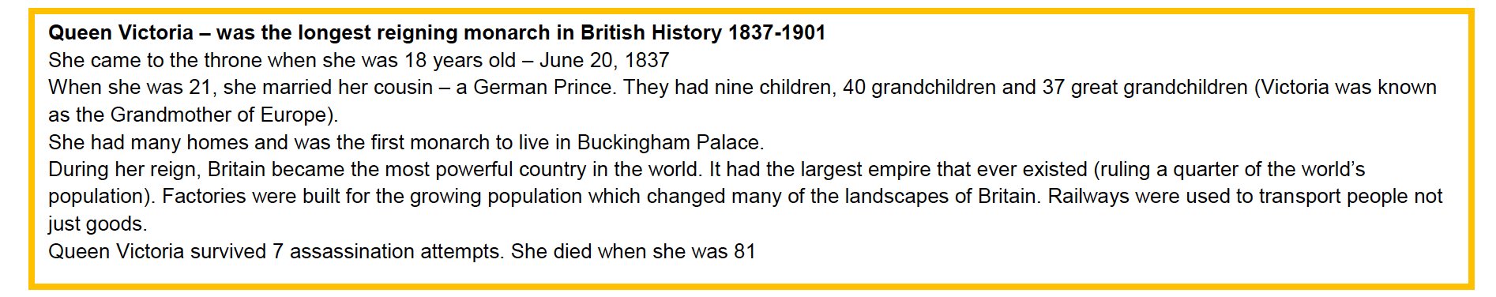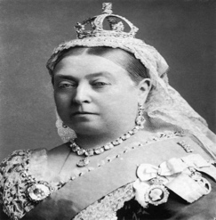

Queen Elizabeth II 1952 – present day
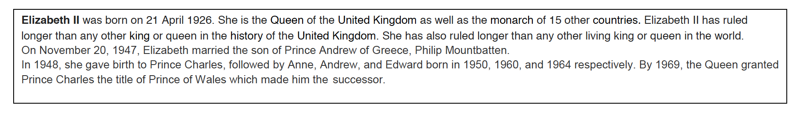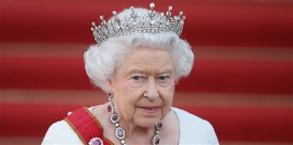

Tier 3 Vocabulary
Abdicate | To retire or resign the throne to someone else.
Baron | A low-ranking male member of nobility.
Heir | The heir to the throne is the next person in line to the throne when the current sovereign dies or abdicates.
Monarch | A sovereign head of state (king or queen)
Reign | The period of time in which a monarch reigns.
Magna Carter | The Magna Carter was a charter signed by King John in 1215. The document was a series of promises between the King and his subjects promising them certain rights.
Sovereign | A king or queen or person having the power to reign the country.

