**Science**

**Living Things and their habitats**

**1. Making New Plants 1**

**To describe the life process of reproduction in some plants and animals by exploring sexual reproduction in plants.**

**2. Making New Plants 2**

**To describe the life process of reproduction in some plants and animals by exploring sexual reproduction in plants.**

**3. Mammals**

**To describe the life cycle of a mammal by exploring the life cycles of mammals in different habitats.**

**\*To describe the life process of reproduction in some plants and animals by describing sexual reproduction in mammals**.

**4. Jane Goodall**

**To describe the life process of reproduction in some plants and animals by exploring Jane Goodall’s work with chimpanzees.**

**5. Metamorphosis**

**To describe the differences in the life cycles of an amphibian and an insect.**

**6. Comparing Life cycles**

**To describe the differences in the life cycles of a mammal an amphibian, an insect and a bird.**

**SMSC**

**Relationships**

Rights / Respecting

1.What are your rights as an individual?

2.What are your responsibilities as an individual?

3. How do rights and responsibilities work in relationships?

**Further SEAL**

4.Who are important to me?

Give and receive a complaint

5.Recognising and coping with embarrassment, in yourself as well as others.

**Topic**

**1. Launceston – its place in Cornwall and its trades**

**2.To explain the significance of mining, agriculture and fishing in Cornwall**

Carnyorth – Levant mine / Children in school – mining project

**3. Windmill Hill Academy**

To use school journal as a source of information

**4. WW2 in Launceston**

To explain how WW2 affected Launceston

**5. The Butter Market**

To explain life in Victorian Launceston and the legacy that the Victorians left behind

**6. Launceston Railway**

To explain what Launceston railway meant to the people of Launceston.

**7 Launceston Castle**

To explain who and when Launceston Castle was built.

**To explain its purpose through time**

To explain how Launceston developed around the castle

**Music**

**Djembe drumming**

**\*pulse**

**\*rhythm**

**\*playing as part of a group**

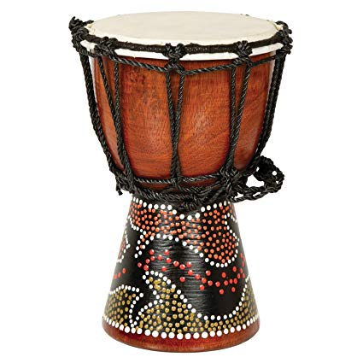

**Computing**

We Are Bloggers

*Become familiar with blogs as a medium and a genre of writing.

* Create a sequence of blog posts on a theme.

*Incorporate additional media

comment on the posts of others.

*Develop a critical, reflective view of a range of media, including text.

**English**

Summer whole (Summer 1 will roll into Summer 2)

* Choral poetry

*Instructions

* Classic literature - Goth Girl

*Biography – Jane Goodall and David Attenborough

Classic Poetry – Charles Causley

**Art**

**Textiles**

**Link to Carnyorth scenes**

**\* sketching landscapes**

**\* Transfer images into:**

**\*Weaving landscapes**

**\*fabric collage**

**\*Batik crayon landscape**

**YEAR 5**

**Summer Overview**

**Launceston / Cornwall / Carnyorth**

**2019**

**Mathematics**

**Multiplication and Division - reinforced**

* **Fractions continued ( amounts, as operators, decimals percentages. Ratios)**
* **Geometry – Properties of shapes**
* **Geometry – Position and Direction**
* **Measurement – converting units (including time)**
* **Measurement – Volume**
* **Area and Perimeter**
* **consolidation**

Christianity

*St Piran and the saints of Cornwall

*The difference between church and chapel

*Methodism

*Local church and chapel

**PE**

*Athletics

*racket and net

Gymnastics

**MFL**

**French – School Life**

*Where are they in the Classroom

*Where are the Objects?

*School subjects

*Maths Lesson

*Asking questions

