Year 3 Homework Learning Grid
Natural Elements 2
In addition to daily reading, please complete one English and Math’s activity and a choice from the other options (they can be done in any order). Homework books need to be handed in every Wednesday and will be returned on the Friday. Learning can be recorded in any format e.g. photos, models etc.…Each Thursday lunchtime there will be a homework club for those who wish to attend or to have a bit of support from myself.

 | 1 | 2 | 3 | 4
Maths | 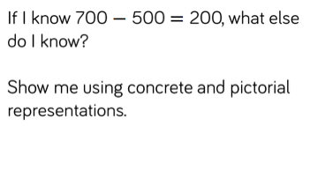 | 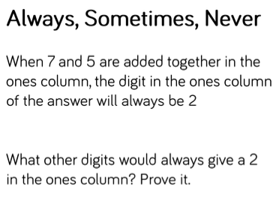 | 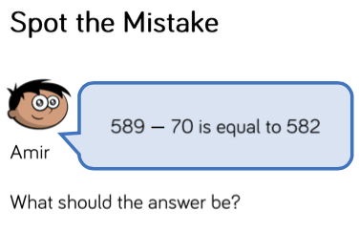 | Practise your multiplication facts on Times Table Rockstars.
Reading | Write a book review for the book that you have just read | Choose a new book to read. Stop reading in the middle of the story. Write down your prediction about what might happen at the end? Were you right? | Write a new blurb for the book that you are reading. | Design a new front cover for the book that you are reading.
Concept (Independent) | Draw and label 5 magnets used in everyday life in your home | Draw a diagram including explanations to show the forces at work in a tug of war | Describe how a magnet works. Use scientific vocabulary associated. Illustrate with labelled diagrams. | Your challenge is to find ten examples of forces in action around your home e.g. pulling the curtains. Design a poster, power point or diagram to present your forces.

