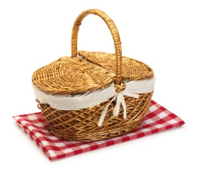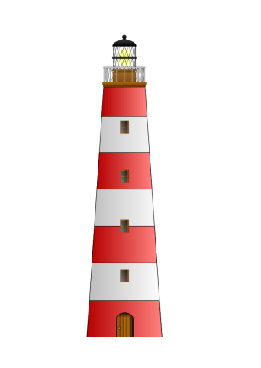

**Science**

* Year 1: Seasons (Autumn and Winter) and Everyday Materials.
* Year 2: Uses of everyday materials

**Physical Education**

* Year 1 will be doing multi-skills on a Tuesday afternoon and dance on a Wednesday afternoon.
* Year 2 will be swimming on a Monday afternoon and multi-skills on a Wednesday afternoon.

**Computing**

* Year 1: **We are Painters** – Illustrating an eBook
* Year 2:  **We are Game Testers –** Exploring how computer games work

**Music**

* Singing – practising/performing the Christmas Nativity

**Design and Technology/Art**

* Year 1 and Year 2:

Structures: making lighthouses (evaluate)

**Mathematics**

Year 1:

* Addition and subtraction (within 10)
* Number: Place Value (within 20)
* Geometry: 2D and 3D Shape

Year 2:

* Number: Addition and Subtraction
* Number: Multiplication and Division
* Measures: Money

**SMSC**

* Getting on and Falling out
* Anti-bullying week
* Daily and weekly reflection time
* R-Time
* British Values

**English**

*In addition to Guided Reading, Phonics/Spelling and Handwriting lessons, children will be studying:*

* Year 1 and 2: Stories/poems by significant authors and instructions, including: The Lighthouse Keeper Stories.

**Religious Education**

* Beliefs, Teaching and Sources
* *What do people believe about God, humanity and the natural world?*