Fire to Forts- Autumn Term - Year There

Well what a busy six weeks we have had. Children in Year Three have been actively engaged in the Topic Fire to Forts. The children have been involved in many practical learning activities as we believe the more active and practical learning is, the more children become engaged and learning becomes real. Below you will find a series of learning activities that have taken place. The best way to keep current with our learning activities is to follow us on twitter at @ADMAT_WHA. You can ask you child to talk about their learning at home. We are excited to start our new project- Extreme Earth after half term.
Art: We have discovered drawing pencils and used these to create line, tone, shape and form when drawing Stone Aged animals. We gave peer feedback using the Austin’s Butterfly model to improve our drawings.

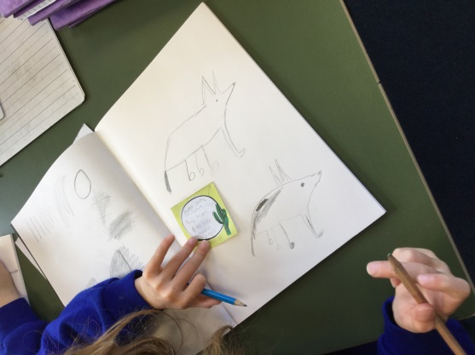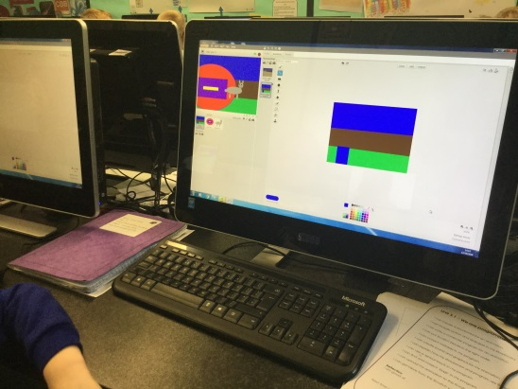
Computing: Using animation programmes we created our own animations of our English text: How to Wash a Wolly Mammoth.
Design and Technology: Creating our own structures using clay. We created Beakers as part of our Topic focus on the Bronze Age.

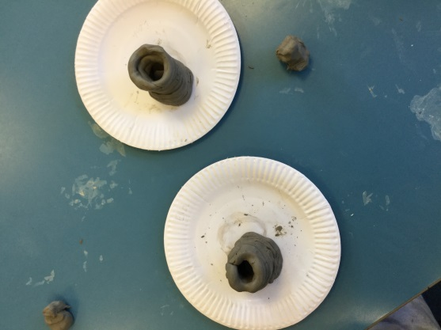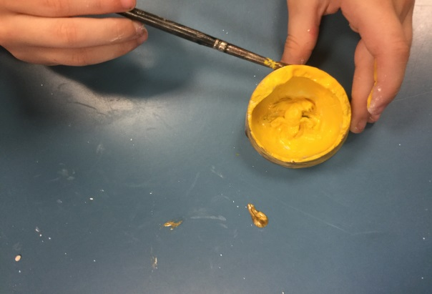
Science: We have been finding out about Rock Formation and Creating our own Fossils using different materials to help us learn new concepts.

