National Curriculum Intention (s):
Identify the geographical regions and key topographical features of the United Kingdom and understand how some of these aspects have changed over time: Coasts.

Key Information
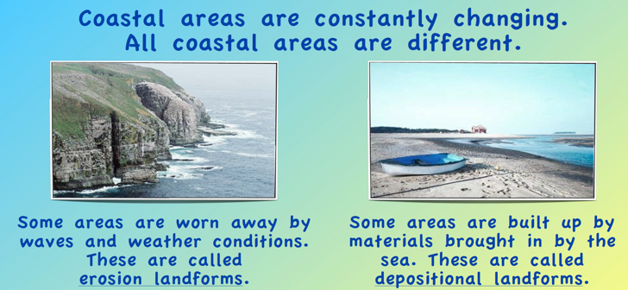 |  | 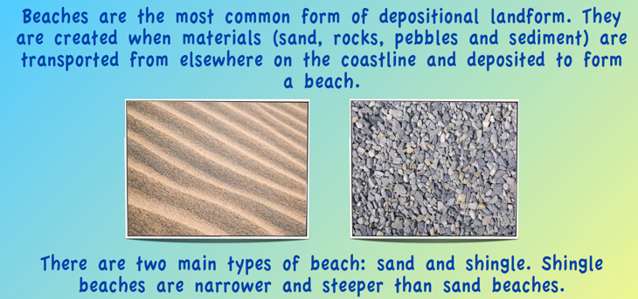
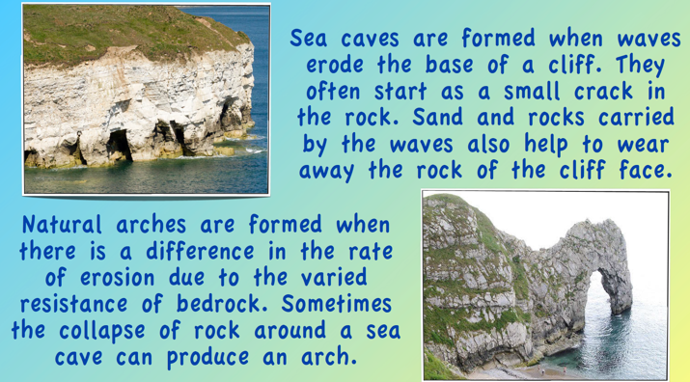 |  | 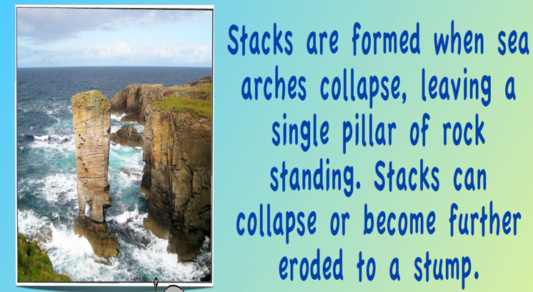
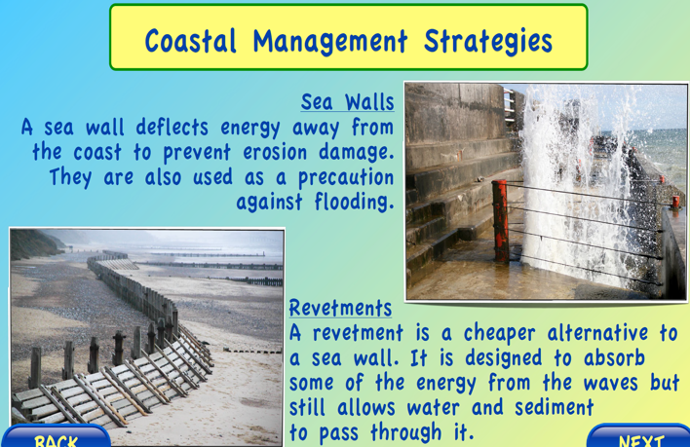 | 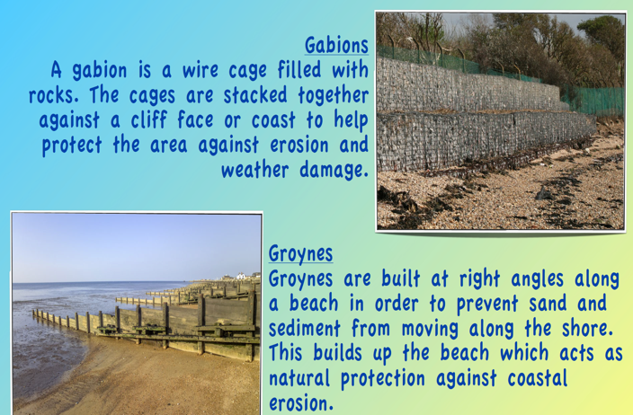
Dates and figures
In 2004, an earthquake off Indonesia caused a tsunami to sweep across the Indian Ocean, swamping coastal towns in Indonesia, Sri Lanka and distant Africa. Over 200,000 people lost their lives.

Tier 3 Vocabulary
Arches | A natural tunnel cut through the headland.
Depositional landforms | Areas built up by materials brought in by the sea.
Erode | Wear away.
Erosion landforms | Areas worn away by waves and weather conditions.
Gabions | A wire cage filled with rocks.
Groynes | A low wall built on a coast to stop waves moving sand and rock along the beach.
Revetment | A structure which protects against erosion.
Sea caves | A natural hollow in a cliff.
Sea walls | A wall built to stop the sea flooding the land.
Stacks | A pillar of rock in the sea.
Tsunami | Giant wave cause by an earthquake or erupting volcano

