National Curriculum Intention(s):
- To use basic geographical vocabulary to refer to:
Key physical features, including: beach, cliff, coast, forest, hill, mountain, sea, ocean, river, soil, valley, vegetation, season and weather
Key human features, including: city, town, village, factory, farm, house, office, port, harbour and shop (Geography National Curriculum page 2)
-Use aerial photographs and plan perspectives to recognise landmarks and basic human and physical features. (Geography National Curriculum page 3).
-To learn about significant historical places in their own locality (History National Curriculum Page 2).

Timeline of Key Events
800AD | The first castle as we know them was built.
Around 1068 | Launceston Castle built by Robert the Count of Mortain.
1080 | Windsor Castle was built.
1227 | Launceston Castle rebuilt in stone by Richard of Cornwall.
1549 | Launceston Castle captured by rebels
1956 | Launceston Castle open to visitors.

Key Numbers
800 | There are 800 castles that have visible remains in England.
300 | 300 castles in England have brick remains and still look like castles.

Key Places
Launceston | Our local castle.
Windsor Castle | This is the largest castle in England and one of Queen Elizabeth II’s residences.
Berkhamsted Castle | Oldest castle in England.
Key Figures
Robert the Count of Mortain | First built Launceston Castle.
Richard of Cornwall | Rebuilt Launceston Castle in stone.

Interesting Facts
- Launceston Castle was originally called Dunheved.
- A wall was built around the town of Launceston and this made Launceston the only walled town in Cornwall, showing how important it was.
- When the castle was falling to pieces, it was used as a prison.

Tier 3 Vocabulary
Moat | A deep, wide ditch surrounding a castle that is usually filled with water as a defence against attack.  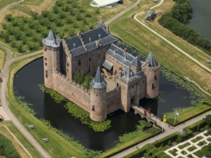
Dungeon | A strong, underground prison cell.
Portcullis | A heavy, vertically closing gate usually made from wood, metal or both.  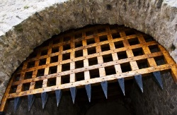
Turret | A small tower on top of a larger tower or at the corner of a building or wall.  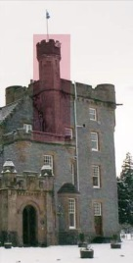
Ramparts | A defensive wall of a castle or walled city, having a broad top with a walkway.  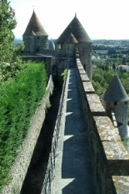
Drawbridge | A bridge, especially one over a castle's moat, which is hinged at one end so that it may be raised to stop people crossing or to allow vessels to pass under it.  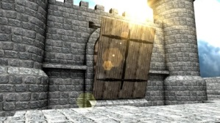
Rebellion | The action of resisting authority, control, or convention.
Invasion | An unwelcome intrusion into another's domain.
Physical feature | A feature that is naturally created, such as a hill, sea, a mountain.
Human feature | A feature that is created by humans or man-made such as a road, a house.

