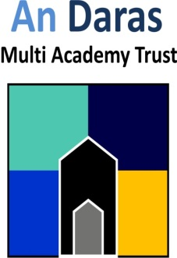 | Visible Learning at WHA  Summer 2018
Visible Learning Update

Did you know at Windmill Hill Academy, we have been working closely with our An Daras Schools on a learning journey called ‘Visible Learning’? The Visible Learning improvement model is based upon the principles developed by John Hattie’s research.

Recently we had a visit from Wendy Delf, our Visible Learning External Mentor with Mrs Saunders, our MAT Visible Learning Leader. Both adults spoke with members of staff, children across the school and looked at our learning environment and children’s learning books.

The visitors were pleased with our learning journey but also gave us some recommendations on our Visible Learning Journey for next year. You can find out more information from our website. Our Visible Learning coaches are Miss Jones (Foundation teacher) and our new additional coach will be Mrs Charrett-Dykes (Year Three Teacher). We hope to share with you our Visible Learning Journey throughout the year next year in our newsletters.

What is Visible Learning?

Pupils take ownership of their own learning. They know where they are within the curriculum and what their next steps are. Using their goals grids they can track their own progress. The pupils know what to do when they come across something they don’t know and have strategies to progress with their learning. Pupils seek feedback and respond to it, and more importantly they give feedback to staff about their teaching.

Pupils are active in their learning and are assessment capable. Assessment Capable Learners can ask and find the answer to: Where am I going? How am I going there? Where to next?

Pupils can employ a range of meta-cognitive strategies developed through a shared language of learning. Pupils see learning as hard work, have a ‘can do’ approach and a desire to succeed.

Through the introduction of Visible Learning, we encourage children to really challenge themselves. Each class, has a ‘learning pit’ when they find the learning difficult and challenging. The children talk about where they are with their learning in relation to the pit, and work on strategies and skills to assist in their learning in order to achieve their learning intention and success criteria. We encourage the children to place themselves in the pit as this is where learning is at its best.

Visible learners are able to

- Understand their learning intentions
- Know and are challenged by the success criteria
- Develop a range of learning strategies
- Seek feedback and look for their next steps in learning

Follow our Twitter Feed

Did you know Windmill Hill Academy has a Twitter account? The aim of our Twitter account is to showcase the learning that is happening and keep parents informed about exciting learning projects such as ‘Year Three Art Weaving Day’. Please do follow us on twitter directly or follow us through the website. We use twitter to tweet about our learning displays and examples of visible learning. Come and join our community.

