Year 3 Homework Autumn 2nd Half Extreme Earth
Homework in KS2 involves independent learning. Each week the children choose one learning activity centred on curriculum topic we are studying in class. How the children research or present their findings is entirely up to them. They can use computers, books, observation, questioning or experimenting; draw, paint, write or build. The only requests are that the work be carefully and attractively presented and that children don’t copy out screens from books or the internet.
Each week we will set aside some class time for sharing the homework. Your support while your child is doing their homework is greatly appreciated but please do not be tempted to do it for them. The important things are that your child enjoys what they are doing, discovers something new and practises learning independently.
Your child should also read daily, practise spellings within their homework book and learn the statutory list for Y3/4 (some may still be working on Y1 and 2 spellings for this term). They need to learn multiplication / division tables for their Around the World Maths Assessments. There may choose a small amount of Maths or English learning. Thank you for your continued support.
These are the activities for you to choose from over the course of this half term. Please bring homework books in for a Wednesday to be marked and returned by Friday. Larger homework projects/ computer based project can be brought in at any time and will be shared at the end of a day with the class.
Topic  Extreme Earth  Please choose throughout the Half Term  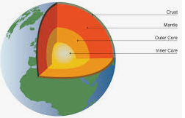 | Set up your own volcano experiment at home and write out your investigation. What equipment did you need? What did you observe? Research and find out where volcanoes are within our planet. Which volcanoes are still active? Which are dormant? Find out about inside the Earth. Can you name the different sections of the Earth through to the Earths core? Using Google Earth or similar locate the mountains and volcanos in the world.  Draw and label a volcano. Research and find out about the highest mountains in the world. Draw pictures and label them. Research and record. How is an earthquake created? How are mountains formed? Draw a map (birds eye view) of your garden or local area and plot and label the key features.
Science  Rocks and Soils | We are learning about soils this half term. Please choose at least one of these learning activities.
 | Can you suggest what rocks would be best for different purposes?  E.g. What rocks are best for building houses? | Explore different soils and identify what is the same and different about them. | Test some different soils.  Research and find out about the different types of soils. Red Soils? Chalk soils? Clay soil? What is the soil profile?
English | Learn a Classic Poem and recite it in Class. | Write your own newspaper report about what we have learnt about rocks or fossils. | Write your own set of instructions for how to make a Celtic Roundhouses or a Bronze Aged Beaker using Clay.
Maths | Can you break the code?  The first number is half of 8.  The second number is double the first number.  The third number is a quarter of 8.  The last and first number add up to 10.  Try and create your own. | 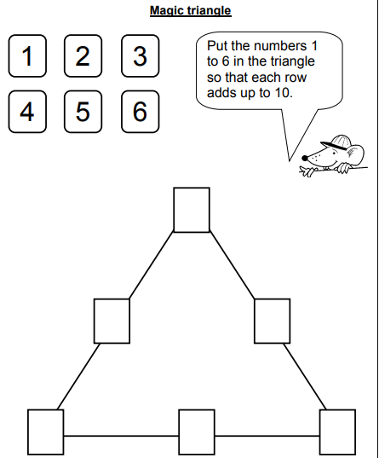 | Find the Missing Digits Create your own.  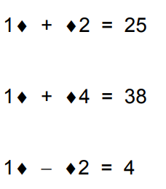
Essential Home Learning:
- Know your multiplication facts for 2/3/4/5/8/10
- Be able to spell in words numbers to 100
- Be able to spell all the words from the Year One and Two list
- Read every day, on some days complete a reading menu activities and record in your yellow reading record on in your homework book.
Enjoy!

