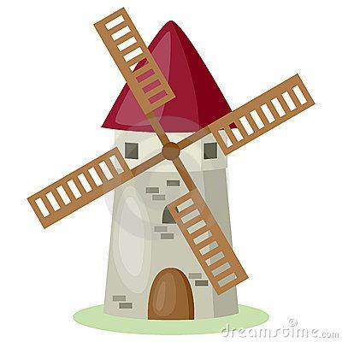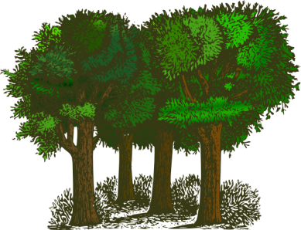

**SMSC**

* Relationships
* British Values
* Daily reflection time
* R time
* British Values

**Religious Education**

**Leaders and teachers:** How do we care for our world?

What makes a place special?

**Mathematics**

* Year 1: Measurement, multiplication and division and fractions.
* Year 2: Fractions, Geometry (properties of shapes) and Measurement.

*We place a real emphasis on ‘mastery’ in maths so that the learning of new concepts is embedded before moving on.*

**Please can you make sure your child(ren) have wellies/old shoes, a waterproof coat and old trousers which can be left in school for the whole of this half term. Please can all items be labelled with their name including their bag as they will be taking part in outdoor learning and Wild Tribe activities.**

**Physical Education**

* Year 1 will be doing dance on Monday afternoons and throwing and catching on Tuesday mornings. *Wild Tribe*
* Year 2 will be doing brilliant ball skills on a Tuesday and active athletics on a Friday afternoon.

**Music**

* Year 1: Your imagination (singing and performing).
* Year 2: Friendship (singing and performing).

**Science**

* Year 1: Plants
* Year 2: Living things and their habitats

**Geography**

**Geographical Skills and Fieldwork**

Year 1: identify the features of the local environment.

Year 2: sorting and grouping physical and human features in the local environment.

**Computing**

* Year 1: ‘We are good digital citizens’ (online safety) and ‘We are Storytellers (producing a talking book).
* Year 2: ‘We are online behaviour experts’ (online safety) and ‘We are Detectives’ (collecting clues).

**English**

* *In addition to Guided Reading, Phonics/Spelling and Handwriting lessons, children will be studying:*
* Year 1: Stories with a familiar setting (woods), information texts and poems on a theme.
* Year 2: Traditional tales, explanation texts and challenging poems.