Year 4 Homework
Autumn 1
SMSC | Initial Challenge: Can you introduce yourself and your interests?  On the first few pages of your homework book, introduce yourself (and your family).  Can you do this by using a combination of ideas (for example; writing, drawings, and photographs) to help you explain what your hobbies and interests are?  What do you like? What are your hobbies? Who are your family? Do you have any pets?  What’s your favourite animal? What makes you special?
Science | In Science we have been learning about States of Matter. Can you complete the crossword below?
Science | 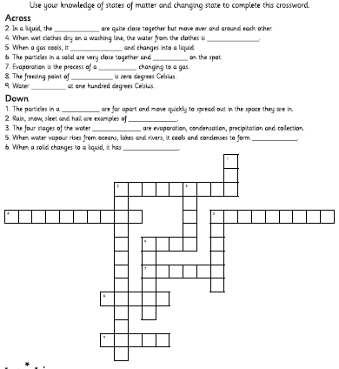
History | We are learning about life in Ancient Greece. What can you find out about the Ancient Greeks?  Can you present your information clearly and neatly? You can choose how you want to record your work. You could use ICT to research and present your work if you would like to. Choose one of the challenges.
History | Challenge 1:  Who was Medusa? Can you write a summary about her? Who was she? How was she defeated? | Challenge 2:  Can you create a fact file about what the Ancient Greeks ate and drank? | Challenge 3a:  Rich families in Ancient Greece had slaves, up to as many as 50. Can you find out how the rich people in Ancient Greece spent their time if they did not have to work?
Topic DT | In topic this term we have been looking at Ancient Greece – can you make one of these?
Topic DT | 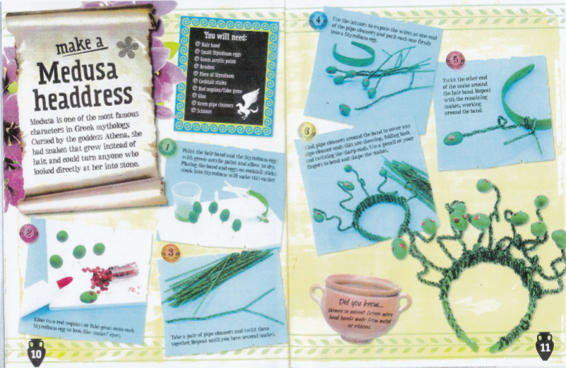  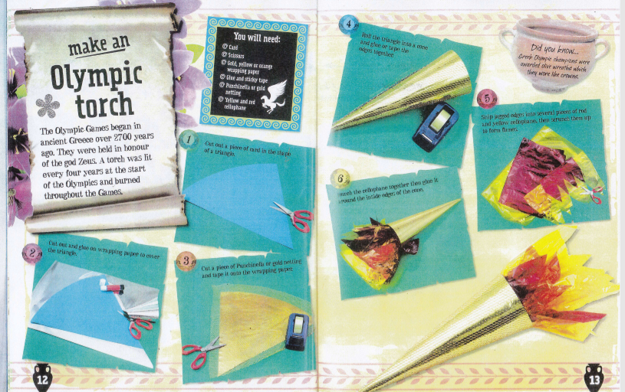
On-going Practise: Please also remember to practice your reading, spellings and times tables every week.
Please make sure you bring in your homework book every Monday so that we can see how you are getting on and keep track of your homework points. We will aim to share our work and return books on Tuesday.

