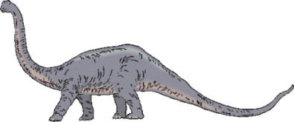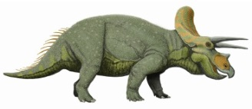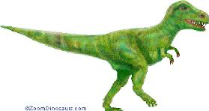

**Computing**

* Year 1: We are responsible internet and device users (online safety) and We are Collectors – Finding images using the web.
* Year 2: We are safe searchers (online safety) and We are Photographers – Taking better photos

**History and Geography**

* Events beyond living memory (National or Global) – Dinosaurs.
* Understand where events fit within a chronological framework and identify similarities and differences between ways of life at different times.

**Visible Learning***:*

* The different learning sails.
* Knowing their learning goals.
* Being assessment-capable learners.

**SMSC**

* Going for Goals
* British Values
* R Time
* Daily and weekly reflection time
* British values

**Religious Education**

* Symbols and celebrations: How and why symbols express religious meanings.

**Mathematics**

* Year 1: Place value (within 50), addition and subtraction (within 20) and measurement.
* Year 2: Subtraction, multiplication, division and fractions.

*We place a real emphasis on ‘mastery’ in maths so that the learning of new concepts is embedded before moving on.*

**English**

*In addition to Guided Reading, Phonics/Spelling and Handwriting lessons, children will be studying:*

* Year 1: Stories and poems related to dinosaurs and information texts.
* Year 2: Stories and poems related to dinosaurs and dictionary lists.

**Art**

* Printing:

Develop a wide range of art and design techniques in using colour, pattern, texture, line, shape, form and space.

**Music**

* Year 1: In the groove. Musical skill: percussion.
* Year 2: Glockenspiel. Musical Skill: compose.

**Science**

* Year 1: everyday materials and seasons (ongoing).
* Year 2: uses of everyday materials.

**Physical Education**

* Year 1 will be swimming on Monday afternoons and gymnastics on Tuesdays.
* Year 2 will be doing dance on Tuesday afternoons and gymnastics on Fridays.