Year 3 Homework Learning Grid
Elements
In addition to daily reading, please complete one English and Math’s activity and a choice from the other options (they can be done in any order). Homework books need to be handed in every Wednesday and will be returned on the Friday. Learning can be recorded in any format e.g. photos, models etc.…Each Thursday lunchtime there will be a homework club for those who wish to attend or to have a bit of support from myself.
 | 1 | 2 | 3 | 4 | 5 | 6
Maths | 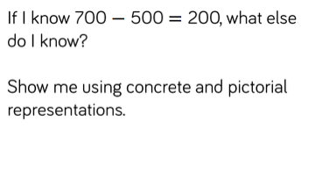 | 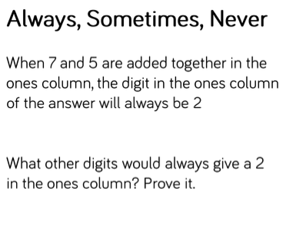 | 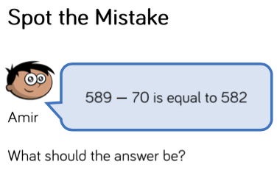 | Complete the missing digits | 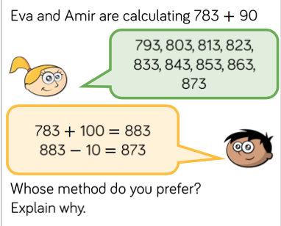 | Practise your multiplication facts on Times Table Rockstars.
English | Write 3 questions that you would like to find out about our new concept of elements. | Collect any newspaper articles about nature and the elements at force e.g. local flooding, extreme weather. | Write an advert for type of food in a Waitrose/M&S  style. | Write a letter to a supermarket to persuade them not to use so much plastic in their packaging. | Pick three random words to write a short story. | Draw a story map for the poem ‘The Owl And The Pussy Cat’
Reading | Write a book review for the book that you have just read | Choose a new book to read. Stop reading in the middle of the story. Write down your prediction about what might happen at the end? Were you right? | Draw an emotion map of the main character from the book that you are reading. | Write a new blurb for the book that you are reading. | Write a new ending for the book that you are reading | Design a new front cover for the book that you are reading.
Handwriting and spelling | Practice some of the year three common exception words in a messy way! Shaving foam, play dough, flour, and chalk…) | Rewrite the blurb of your reading book using cursive joined writing. | Practise writing your numbers correctly making sure that they are around the right way. | Practise your cursive writing by, writing found adjectives e.g. sticky, horrendous, huge. | Practise writing some onomatopoeia words to make them look like the word e.g.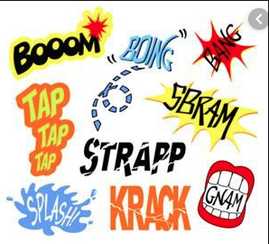 | Can you write the alphabet using cursive writing?
Concept (Independent) | Keep a diary of the weather and use known symbols. | Draw a scale map of a room in your house. | Draw a map of a journey that you take. Remember to use road names! | Sample or cook some French food and share with your family. | Design a French menu. | Collect food packaging and make a graph or tally of where your food comes from.

