What is Forest Schools?

Forest School works with children in the outdoors over a period of time, introducing responsible risk-taking and setting children up to achieve. Children are supported in their learning and encouraged to explore the outdoor environment and appreciate nature.
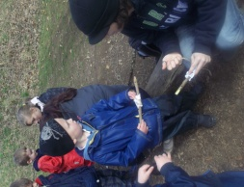
Forest School leaders use learning and teaching strategies, which develop confidence, emotional resilience, independence, language and communication skills and increase levels of physical activity and mental wellbeing.

Why do Forest Schools?

forest Schools is a philosophy to equip children, with an education that encourages an appreciation of the natural world through a series of visits to woodland areas over an extended period of time. Children are encouraged to be independent and by working on small achievable tasks in a stimulating environment they are able to build their own self-esteem and develop social and behavioural management skills.

When will it take place?

One afternoon a week (to be confirmed in the Autumn term) the children will take part in Forest School, regardless of weather conditions (except high winds). Your child will need full waterproofs (including trousers and jacket) and wellies in school to ensure they are comfortable and dry when outside during Forest School. During hot weather your child will need to have sun cream and a sun hat. Remember – there is no such thing as inappropriate weather – only inappropriate clothing!

Over the school year, one class at a time undertake a six-week block of Forest School’s in windmill woods. We will follow themes such as the changing seasons, trees, sticks and leaves, British birds and animals, flowers in the local environment and minibeasts. Den building, tool work and knot tying are regular activities that will take place throughout the year.

Being Safe

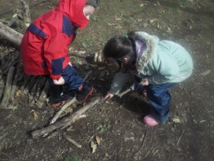
Safety at Forest School is highly important. Detailed risk assessments are standard practise in our school for visits, visitors and the activities that take place in our school environment and at Forest School. A Forest School handbook is in place that covers all risk assessments, procedures and Forest School practise. All staff and volunteers who participate in Forest School are required to read the handbook and this is available for parents to read.

Who will run the sessions?
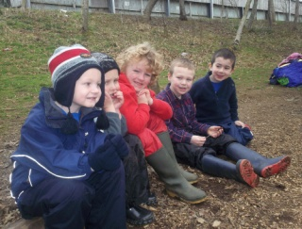
Mrs Whitley is now a Forest Schools leader and is qualified to run sessions. She will be planning and taking the lessons with the supports of the other teaching and support staff.
Volunteers Wanted
IF YOU ARE ABLE TO HELP AT THESE SESSIONS PLEASE SEE AN ADULT FROM YOUR CHILDS CLASS

Launceston Primary School

